|  |  |
| --- | --- |
| User Dcumentation  Customer | Abstract  Gone Sin (going down from high places without making any own efforts)    By Bit-Geeks |

# Introduction

Gone Sin Mal is a mobile platform for all restaurants or food shops which allows them to host their information. Moreover, they can even use the coin system provided by the platform to promote the sales or attract the customers.

Customers can gain coins from the restaurants, which use this application, by eating and with those coins, they can use it back when they go and eat at any restaurants that use the application. The difference between this application and other ones is that our coin system is universal, which is any gain coins from one restaurant can be used for all of the restaurants (all of the restaurants that use our application). Additionally, customers can get special promotion coins given by restaurants, which can be only used on that particular restaurant.

# Navigation Bar

This is the navigation bar of Gone Sin Mal (Customer-side) where you can navigate to another page or screen.

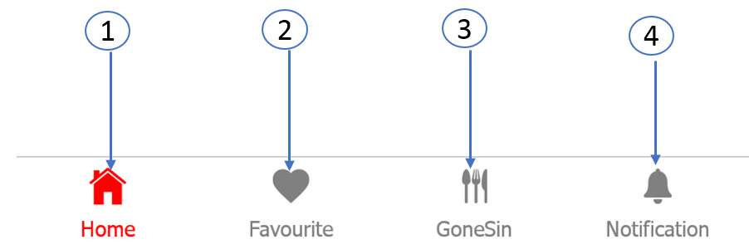

1. You can view Home page of the Customer by clicking Home button
2. You can view the favorite restaurant list that you added by clicking Favorite button.
3. Gone Sin Button is displaying Gone Sin List that is customer get free special coins from special restaurant
4. You can view Notification Message by clicking Notification button

# Home Page

This is the home page of Gone Sin Mal (customer-side) where you can view the different restaurants that register in Gone Sin Mal application.

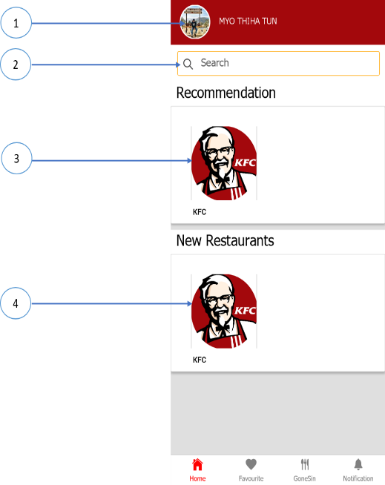

1. By Clicking User Profile or User Name, you can view the user information and coins information and Specific QR Code
2. Filling the text field of the search button, you can view the restaurant that related with search data
3. Clicking the Image of the recommendation restaurant can view the detail information of the restaurants
4. Clicking the Image of the new restaurant can view the detail information of the restaurants

# User Profile

This is the profile of the customer who enter the Gone Sin Mal app with their valid username and password. And can view the specific QR code that can use in restaurant applying Gone Sin Mal application.

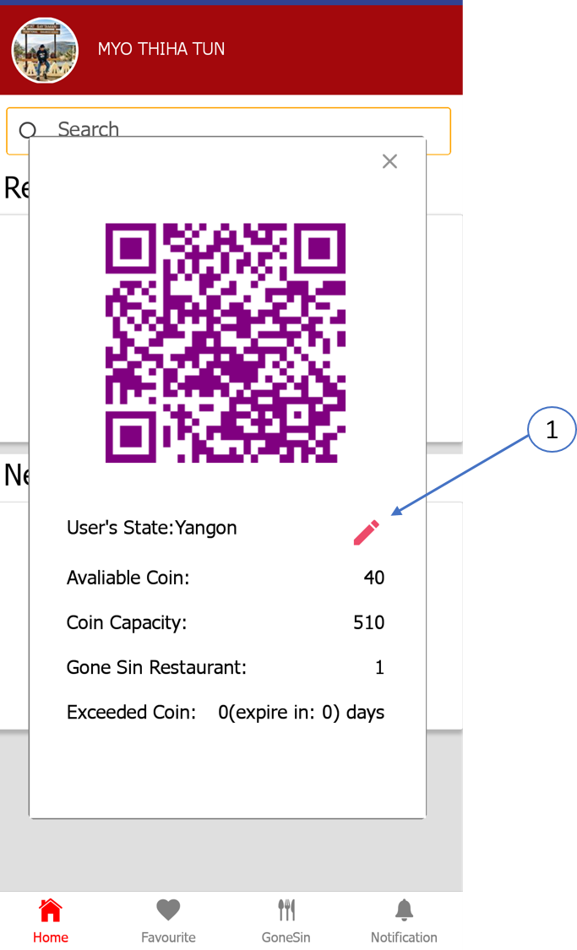

1. You can view the location and change the user state by clicking the Edit Button

# Restaurant Page

This is the Restaurant page of Gone Sin Mal app that you can view specific restaurant that you enter.

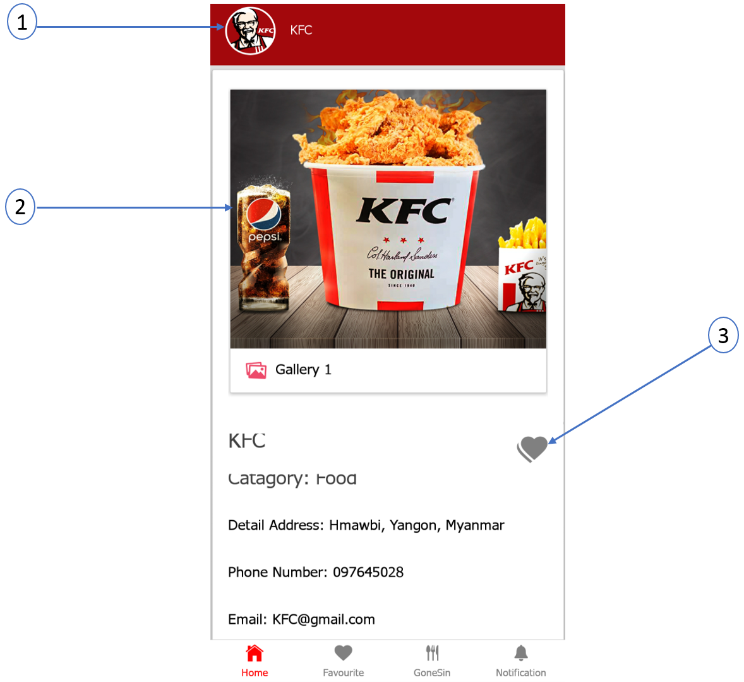

1. By clicking restaurant profile, you can view the restaurant information
2. By sliding the gallery of the restaurant, you can view the different image of the specific restaurant
3. Clicking Heart button can add restaurant favorite list

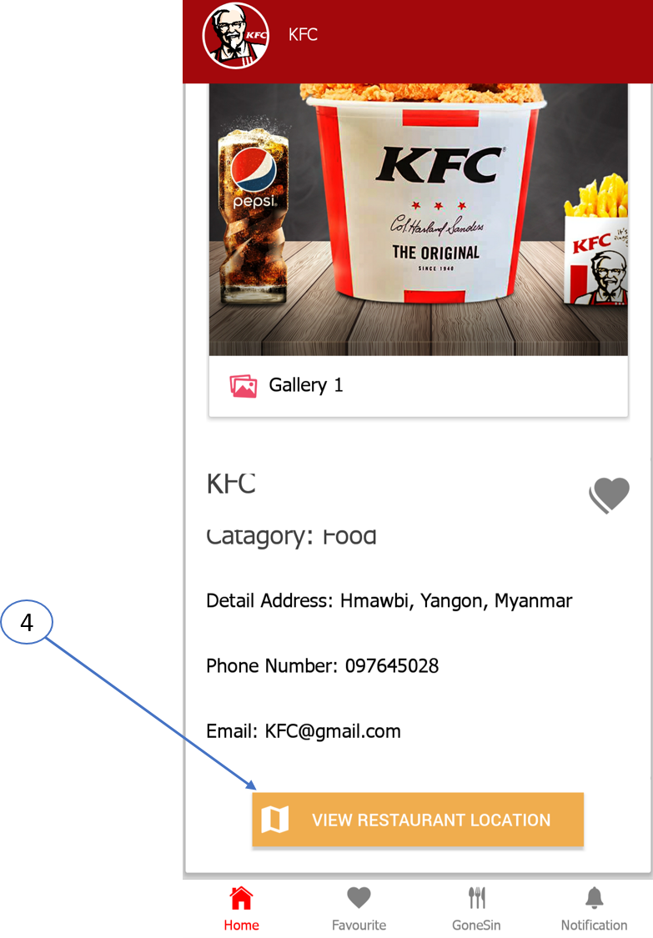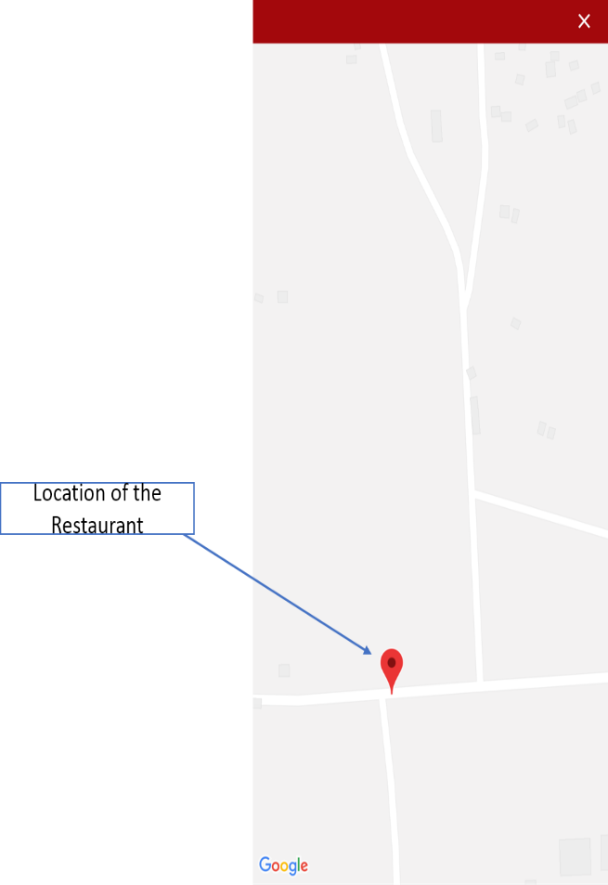

1. You can view the map location of the restaurant by clicking the view restaurant location button

# Favorite Page

This is the favorite page of Gone Sin Mal app where you can view the favorite restaurant that you added.

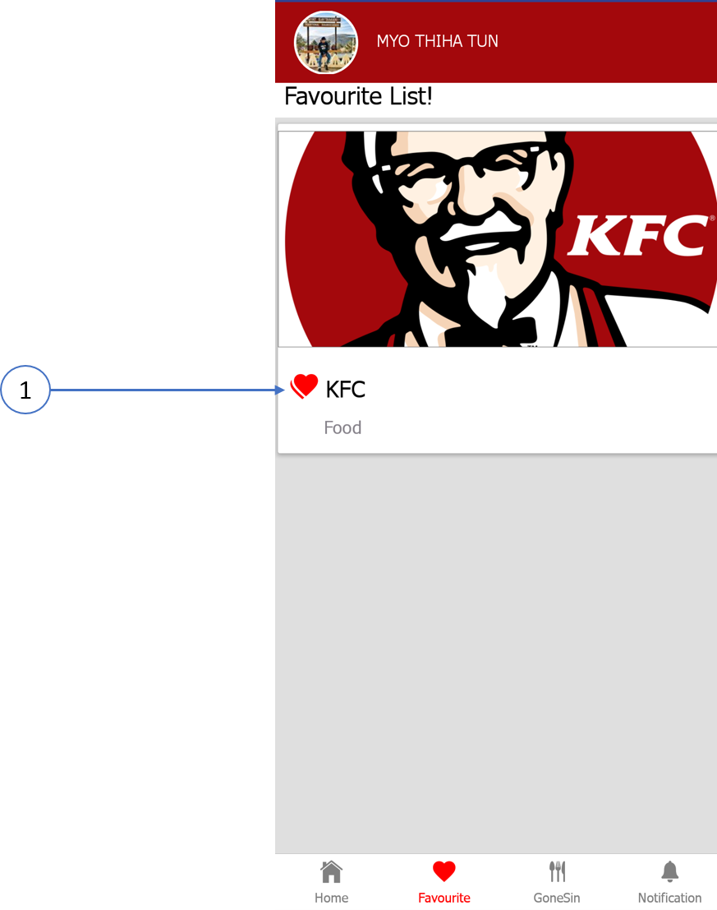

1.This Heart Button can add or remove from the Gone Sin Mal favorite list

# Gone Sin Page

This is the Gone Sin page of the app and you can view the list of the restaurant that is you get special coin from specific restaurant.

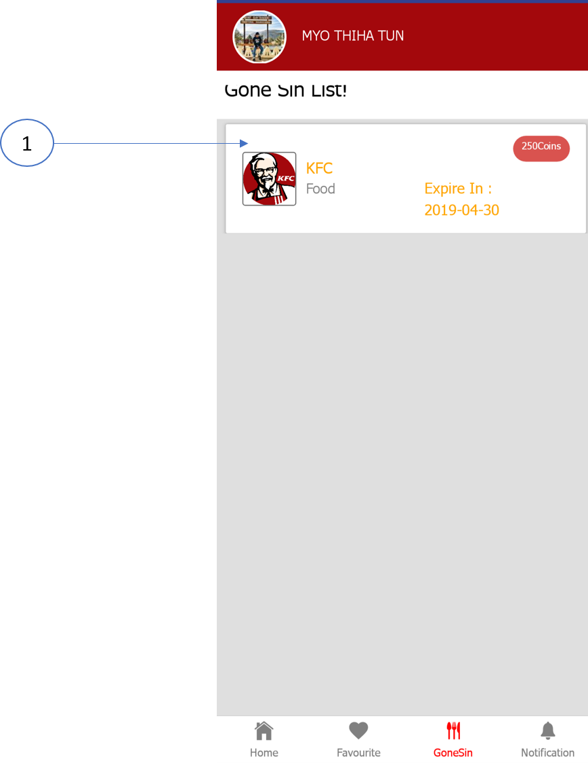

1. Clicking the restaurant logo that show in Gone Sin page will show the specific QR code for Gone Sin

# Notification Page

This is the notification page of the Gone Sin Mal application where you can see the notification message for the specific customer.

